How I’m modifying the Hyde theme

I got Hyde from this person

<https://github.com/jvanz/pelican-hyde/tree/1def3dd97609105f6ae31f0f88ab5ae6a94aa0c5>

but I wanted to modify to look more like Rams

<https://wordpress.org/themes/rams/>

Here’s my initial site

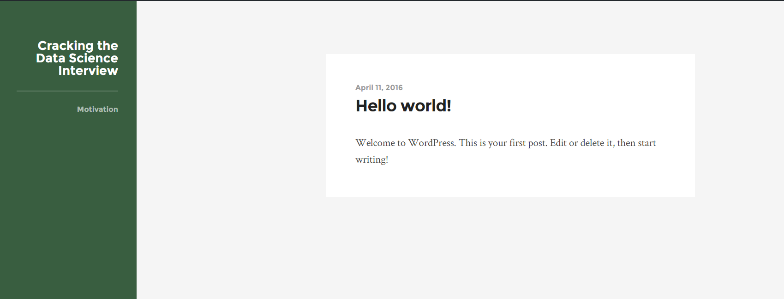

Let’s use Chrome’s awesome inspector tool to learn where stuff is

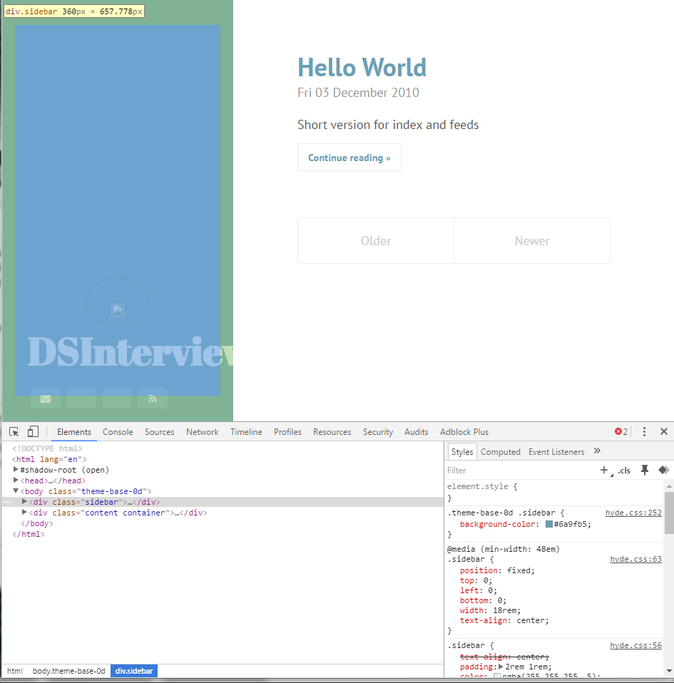

From the stylesheet I can see where the colors are stored

Time to modify Hyde.css/ Looks like there’s themes in here. Let’s add our own.

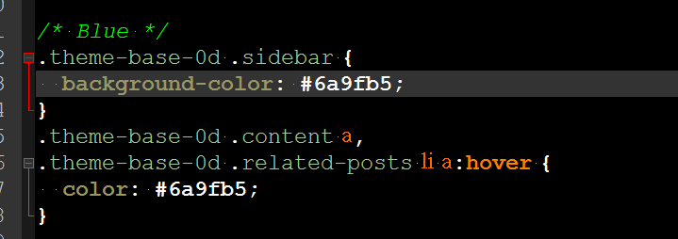

Added a dark green theme

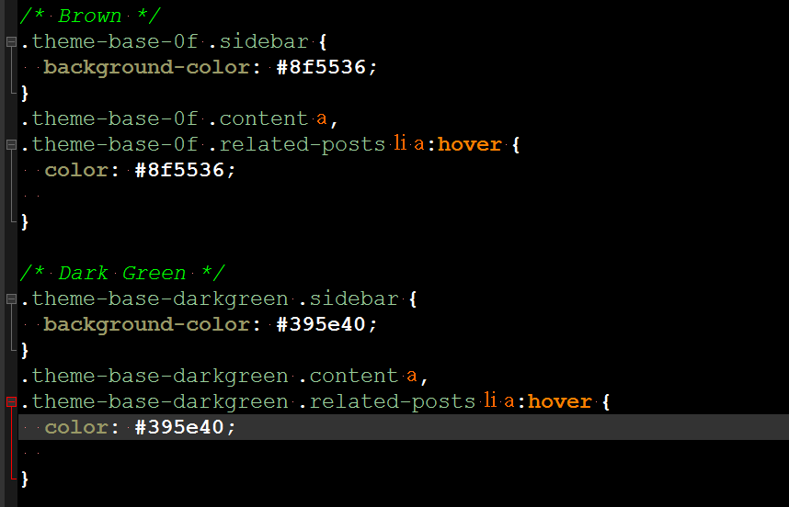

Edit the body to add the dark green theme

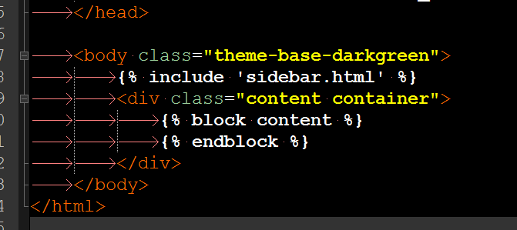

Ok let’s modify the title in Pelican.conf

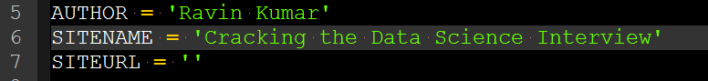

Also modifying the font-family property in hyde.css to be 'Montserrat', sans-serif and adding a bunch of other properties. We also need to add link to Monserrat in body

<https://www.google.com/fonts#UsePlace:use/Collection:Montserrat>

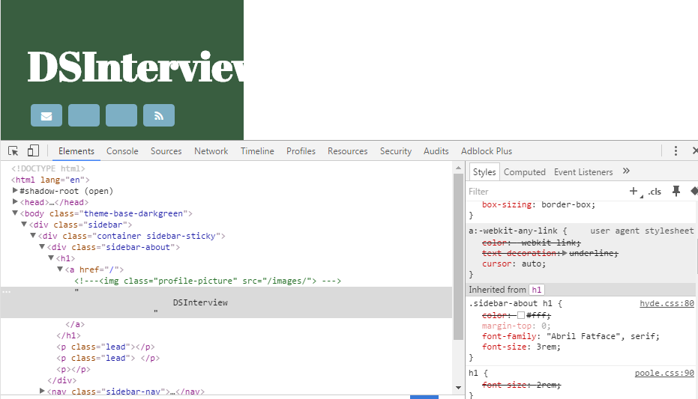

Modified css

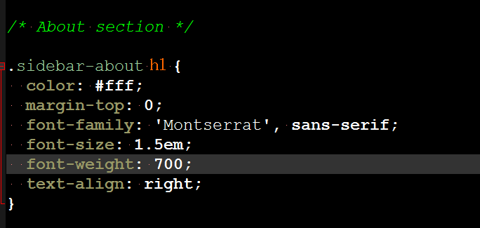

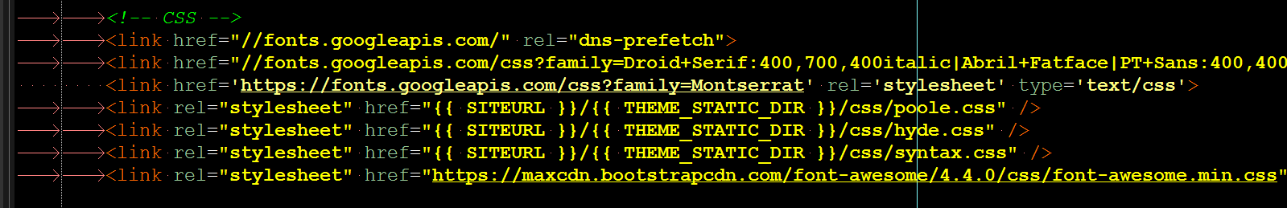

Ok now that looks a lot closer

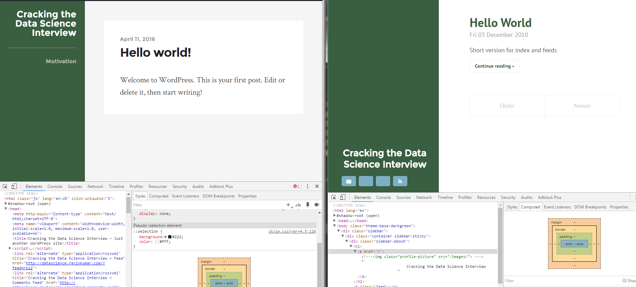

Ok now time to edit the width. The Hyde default profile includes a lot of social links. I likely won’t be using these links so I’m going to change them in the Jinja template